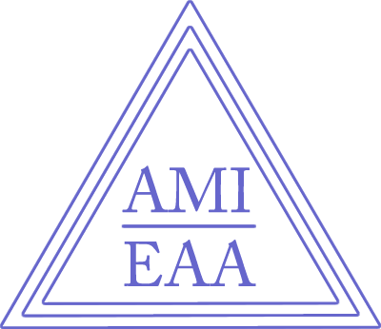
AMI-EAA provides a supportive community for the exchange of ideas and
promotes the principles of Montessori education

AMI-EAA Board Meeting Minutes
October 8th, 2016
GoToMeeting
Attending: Amanda Cade, Allyson Creel, Anna Discenzo, Rachel Eberhard,
John Hooper, Wendy Tye, Gayle Waner
- Minutes and Officers’ Reports
Minutes for July, 2016 board meeting in Squamish, BC, Canada were approved.
Agenda was approved.

II. Organizational
US Affiliate Structure
The affiliate structure was discussed at length by the board.
Action: The board members will privately send their pros and cons to the Chair by October 22nd (two weeks from the date of the board meeting).

Refresher Course 2017, Austin, Texas
Phyllis Pottish-Lewis will be the presenter; Nadine Romig will be the elementary liaison.
Additional presentations will be one for parents about Children after Montessori; and Anti-Bias Workshop, and a Dyslexia workshop.
Phyllis will work with Anna to post handouts from her presentation to the EAA website.
Erik Rivas-Rivas is working on an EAA get-together in the area (within walking distance of the hotel).

Summer Conference 2017, July 9th-14th, South Carolina
The schedule should allow for a day for arrival, three days of presentation, a day for a “going out”, and a final day for an EAA board meeting.
Rachel (Conference Coordinator) is starting to receive presentation proposals. She will also check with people who made proposals in the past (but didn’t present) to see if they’re still interested.
There is a training center and school in the area- possibility of a tour?
There was discussion about putting the ETOT discount on the brochure and application form.
Pedagogical Advisors Update
Phyllis Pottish-Lewis is scheduled to rotate off in February. Possible replacements were discussed, as was the possibility of having her stay on as PA.

Board Transition
We will verify the timeline of informing the membership and sending out the postcard with the by-laws. The post card should go out by Nov. 15th.
John Hooper (the current membership coordinator) will schedule at least two meetings with Amanda Cade (the board nominee) and one including Wendy Tye (the Outreach Coordinator) to talk about transition and the knowledge transfer.
Allyson will give permission for Amanda to access the Shared Dropbox file.
Looking ahead to later transitions- John will send a list of members who have checked “Board” on their membership form.

III. Financial
Budget to date and Summer Conference financial data are in the October 2016 board meeting file.
Budget shows that we made a profit on the SC. Possible reasons are that we stayed one day less, and the difference in the US/Canadian exchange rate.
Gayle (Finance Coordinator) needs to verify the figures in the budget, but feels that EAA is strong financially.

IV. Website
The website has been updated. The Jobs Clearinghouse button will be coming online soon. A form for SC registration proved too complicated and expensive, so Anna declined.
We’ll be looking at whether the handouts currently in the website should be stored in Dropbox, printed as a hardcopy and stored in the archive, or perhaps not worth keeping in the long term.

